Mary  Hloomcraft  System Analyst    Class aptent taciti sociosqu ad litora torquent per conubia nostra, per inceptos hymenaeos. Donec ullamcorper fringilla eros. Fusce in sapien eu purus dapibus commodo. Cum sociis natoque penatibus et magnis dis. | Related Skills  Mauris eget neque  Suspendisse dui  Ut nonummy  Donec blandit  Donec hendrerit  Etiam eget dui  Sed at lorem  Aliquam erat volutpat  Vivamus a mi  Class aptent taciti  Morbi neque  Cum sociis natoque  Professional Skills  Sed ac ligula  Ut tincidunt volutpat  Curabitur posuere  Nullam hendrerit  Contact Info  Address: 123 Park Avenue,  Michigan MI 60689  Email : info@hloom.com  Phone : (123) 456 78 99  Website: www.hloom.com
  Experience
  2008 – Present  Centene Corporation | IT System Analyst  - Vivamus a mi.  - Morbi neque.  - Aliquam erat volutpat.  - Integer ultrices lobortis eros.
  2006 – 2008  Magic Eubos United | Sr. Business Analyst  - Proin semper, ante vitae sollicitudin posuere.  - Sed velit urna, interdum vel, ultricies vel, faucibus at, quam.  - Donec elit est, consectetuer eget, consequat quis, tempus quis, wisi.
  2005 – 2006  The Boeing Company | Programmer Analyst  - Proin semper, ante vitae sollicitudin posuere.  - Sed velit urna, interdum vel, ultricies vel, faucibus at, quam.  - Donec elit est, consectetuer eget, consequat quis, tempus quis, wisi.
  Education
  2000 | Master of Project Management  Washington University
  2005 | Master of Business Administration  Ohio State University
  Portfolio
  RESUME
  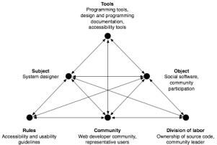 | 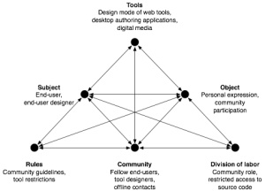
  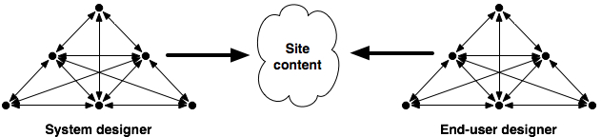
  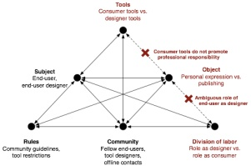 | 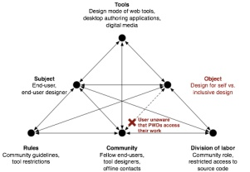

Copyright information - Please read

© This Free Resume Template is the copyright of Hloom.com. You can download and modify this template for your own personal use to create a resume for yourself, or for someone else. You can (and should!) remove this copyright notice before sending your resume to potential employers.

You may not distribute or resell this template, or its derivatives, and you may not make it available on other websites without our prior permission. All sharing of this template must be done using a link to http://www.hloom.com/download-professional-resume-templates/. For any questions relating to the use of this template please email us - info@hloom.com

