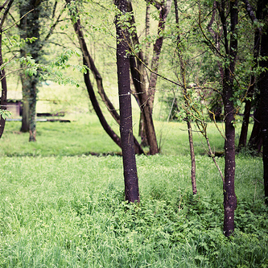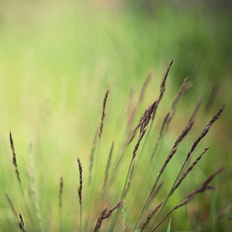

Creative Photographer

portraiture, event and wedding photography

Objectives
Lore mipsum dolor sitamet, consect etura dipiscing elit. Nullae litmetus, auct orsed semvel, eleifendmattisturpis. Fuscetempor, nisi in fermen tum condim entum, nun cturpisvariusodio, sedeleife ndlibero est at tellus.

Education

Bachelor of Fine Arts (B.F.A.), Photography
The Art Institute of Boston, 2009 - 2013

Experience
Freelance Writer & Photographer Self-Employed
January 2013 – Present
Reporter/Photographer
The Carillon, July 2007 - January 2013
Photographer/Editor
Erin Rena Photography, July 2005 - January 2007

+

+
Copyright information - Please read

© This Free Resume Template is the copyright of Hloom.com. You can download and modify this template for your own personal use to create a resume for yourself, or for someone else. You can (and should!) remove this copyright notice before sending your resume to potential employers.

You may not distribute or resell this template, or its derivatives, and you may not make it available on other websites without our prior permission. All sharing of this template must be done using a link to http://www.hloom.com/download-professional-resume-templates/. For any questions relating to the use of this template please email us - info@hloom.com

